GALs Description

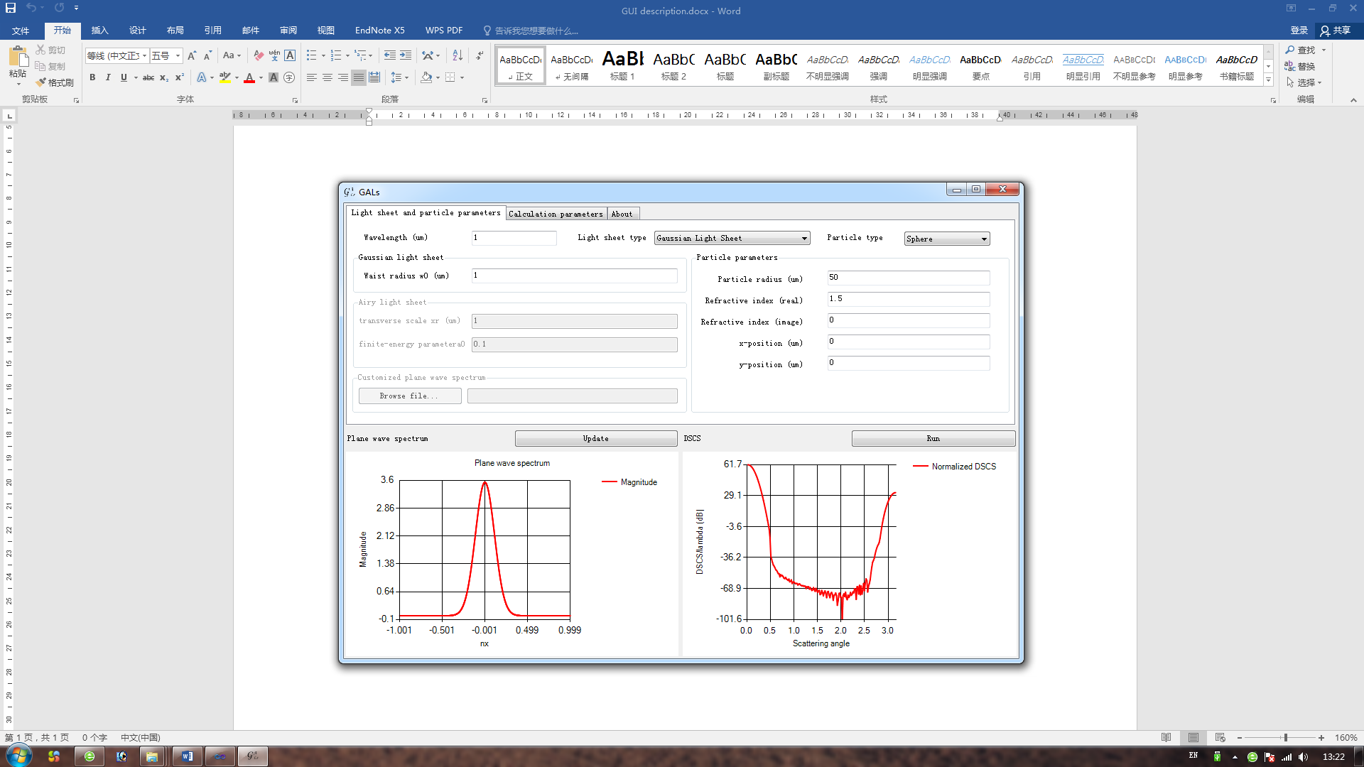

Fig. 1. GUI of GALs.

The GUI of GALs is shown in Fig. 1, including light sheet, sphere and calculation parameter initialization.

1. Light sheet

Three types of light sheets are provided in GALs, including Gaussian light sheet, Airy light sheet, and customized light sheet. The Gaussian light sheet is expressed as

. (1)

The Airy light sheet is expressed as

. (2)

In Eqs. (1) and (2), *k*0 = 2π/λ is the wave vector, λ is the wavelength in the vacuum, (*nx*, *nz*) are the direction cosines of the wave vector, *xr* is the transverse scale corresponding to the light sheet’s mainlobe width, *a*0 is a positive parameter to restrict the beam energy, *w*0 determines the beam radius at the waist.

The curves in the bottom-left part show the amplitude of plane wave spectrum. One can right click the curve to choose which curves, including the magnitude, phase, real and image components.

1. Sphere

The radius, refractive index and position of sphere can be set according to the label text. Note that the refractive index can be complex, which corresponds to an absorbing sphere.

1. Calculation

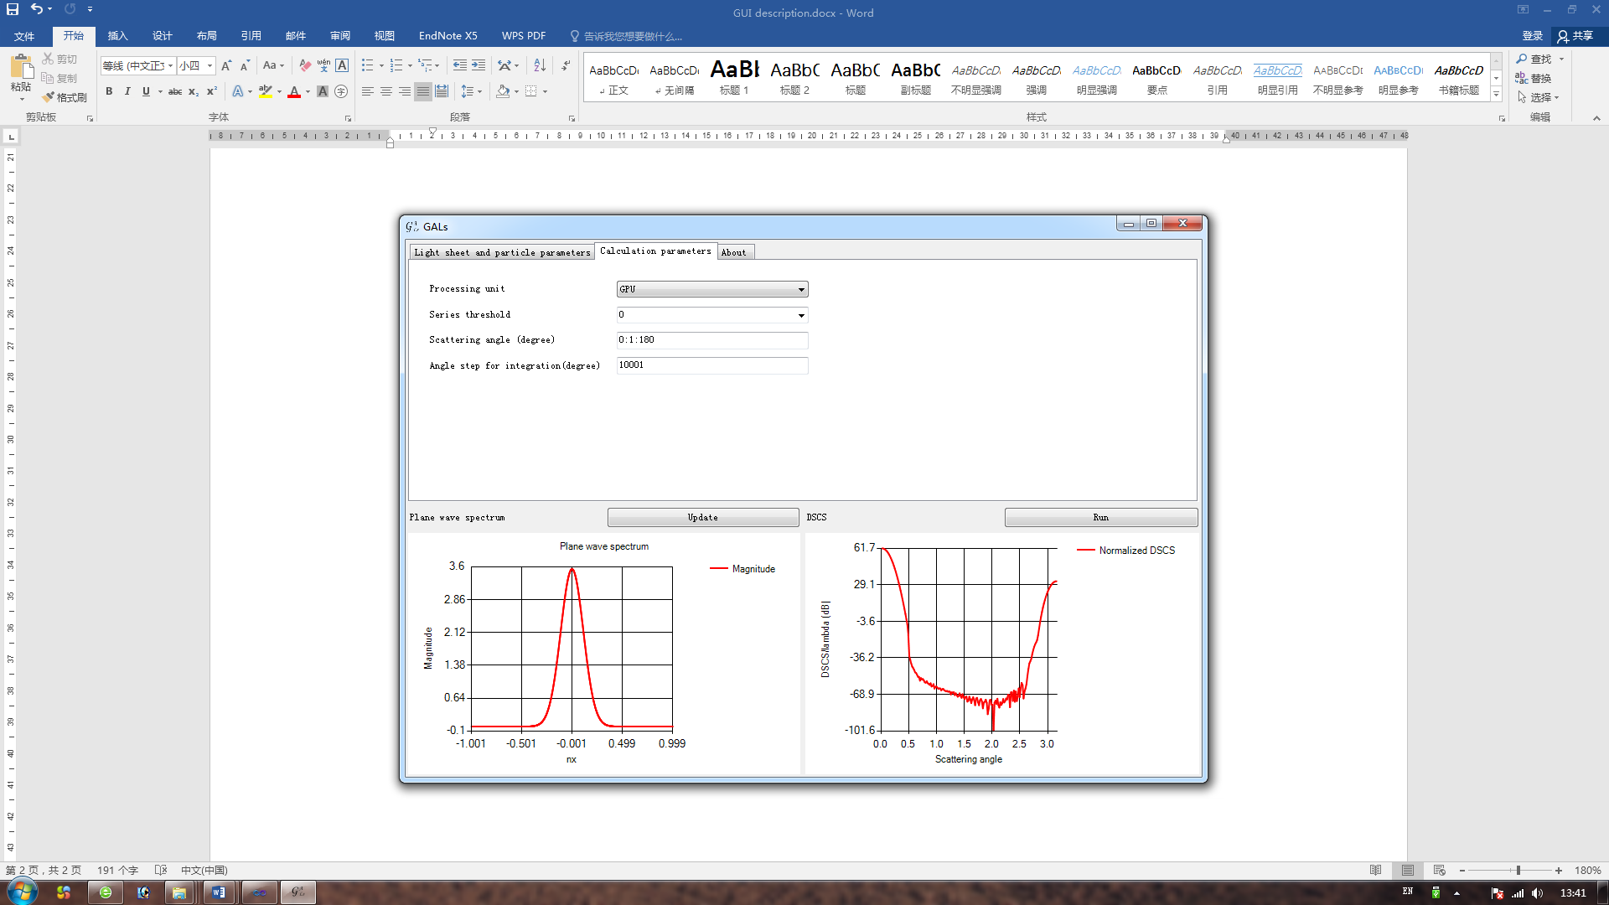

Fig. 2. GUI of calculation parameter setting.

One can choose which unit to calculate the plane wave scattering, including GPU and CPU.

The scattering angle is defined for light sheet scattering. One can use the format of vector definition in Matlab.

The “Angle step for integration (degrees)” is defined to be the scattering angle number for plane wave scattering.

1. Output

The final results of DSCS are shown in the bottom-right part. One can right-click the curve to save the data in the hard disk.